TASK 3: AUTOMATION SYSTEM DESIGN
AUTOMATED CONVEYOR BELT SYSTEM WITH SENSOR – BASED SORTING

SUBMITTED BY: BATOOL FATIMA (ROBOTICS INTERN)

1. Introduction

Conveyor belt systems are one of the most widely used automation solutions in manufacturing and packaging industries. This design integrates infrared (IR) sensors for object detection and quality-based sorting with a servo-actuated reject mechanism, allowing the system to count, inspect, and sort items automatically without continuous human supervision. The system is built around an Arduino Uno microcontroller, which processes sensor inputs and controls the conveyor motor, sorting servo, LCD display, and alert buzzer in real time.

2. Objective

• Automatically detect objects passing on a conveyor belt using IR sensors.
• Count the total number of objects detected and display the count on an LCD.
• Inspect each object against a basic quality/size criterion using a second sensor.
• Automatically sort rejected objects into a separate bin using a servo-driven arm.
• Provide an audible buzzer alert whenever an object is rejected.

3. System Components

• Arduino Uno — central microcontroller that reads sensors and controls actuators.
• IR Sensor 1 — placed at the entry point of the conveyor to detect incoming objects.
• IR Sensor 2 (Quality/Size Sensor) — placed further along the belt to check whether the object meets acceptance criteria (e.g., correct height/size profile).
• DC Motor + L298N Motor Driver — drives the conveyor belt continuously.
• Servo Motor — actuates a sorting arm that pushes rejected objects off the main belt.
• 16x2 LCD Display (I2C) — displays real-time object count and system status.
• Buzzer — sounds briefly whenever an object is rejected.
• 12V DC Power Supply — powers the conveyor motor through the motor driver.

4. System Flowchart

The flowchart below illustrates the complete decision logic of the automated conveyor system, from system initialization through object detection, quality inspection, and sorting.
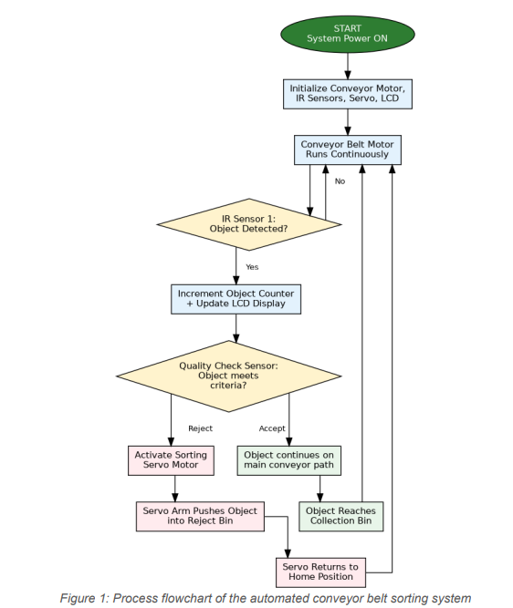

5. Circuit Diagram

The circuit diagram below shows how the Arduino Uno interfaces with the IR sensors, servo motor, DC motor driver, LCD display, and buzzer. The two IR sensors are connected to digital input pins, while the servo, motor driver, LCD (via I2C), and buzzer are connected to the Arduino's digital/PWM output pins

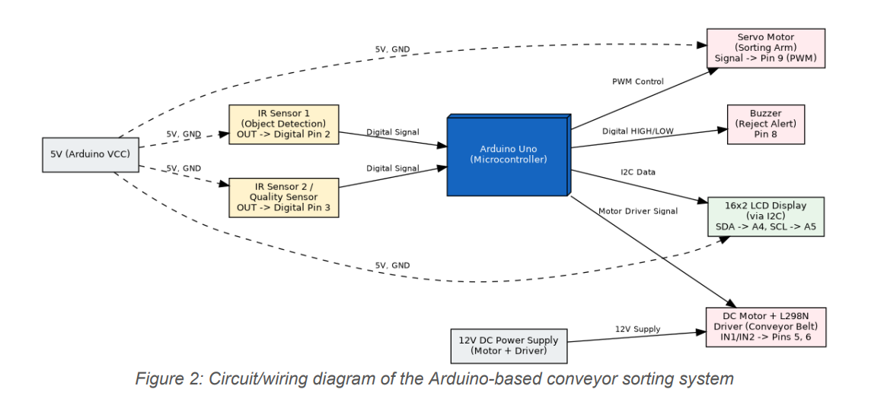

6. Working Explanation

When the system is powered on, the Arduino initializes all connected components and starts the conveyor belt motor, which runs continuously. As an object moves along the belt, IR Sensor 1 detects its presence at the entry point and signals the Arduino. The Arduino increments an internal object counter and updates the count on the LCD display in real time. The object then continues toward IR Sensor 2 (the quality/size check point). If the object satisfies the defined acceptance criteria, it is allowed to continue along the main conveyor path toward the collection bin. If the object fails the check, the Arduino immediately commands the servo motor to rotate, swinging a small arm that pushes the object off the belt into a designated reject bin, while the buzzer sounds briefly to alert nearby operators. After completing the push action, the servo returns to its home position, and the system continues monitoring the belt for the next object. This closed-loop sense-decide-actuate cycle repeats continuously, allowing the system to operate as a fully automated inspection and sorting station with minimal human intervention.

7. Advantages of the System

• Reduces manual labor required for inspection and sorting tasks.
• Improves consistency and speed of quality checks compared to manual inspection.
• Real-time object counting assists with production tracking and inventory management.
• Modular design allows additional sensors (e.g., color or weight sensors) to be integrated for more advanced sorting criteria.
• Low-cost components (Arduino, IR sensors, servo) make the system economically scalable for small to medium production lines.

8. Conclusion

This automated conveyor belt system demonstrates a practical application of embedded systems and sensor integration in industrial automation. By combining simple IR sensors with a microcontroller-based decision process and servo-driven actuation, the system achieves reliable object counting and quality-based sorting without continuous human involvement. This design forms a foundational model that can be extended with additional sensors, networked monitoring (IoT), or PLC-based control for larger-scale industrial deployment

